A
Report

On

Students’ Seminar
Session- 2018-19

Department of Philosophy
Rabindra Mahavidyalaya, Champadanga

Theme:
Concept of Moksha in Indian Philosophy
Venue: Department of Philosophy
Date: February 23, 2019
Organizer: Department of Philosophy
Paper Presenters: Students of Semester VI (Hons.)
Audience: Students of Semester II, IV and VI (Hons.)

Objectives
- Learn a systematic study of ideas and issues;
- Pursuit of fundamental truths, a quest for a comprehensive understanding of the world, a study of principles of conduct and much more.
• Development of Discussion skills, exhibit independence and flexibility of thought, and time management;
- Stimulate listening skills, argumentative skills and critical thinking;

Proceedings
The seminar, hosted by Prof. SuklaSaha, began with the introductory speech given by Prof. Hasina Sikdar, Assistant Professor of Department of Philosophy of the institution. All three technical sessions were chaired by the departmental faculties. Prof. Soumitra Das acted as judges. Prof. Sima Choudhury monitored the whole session. There were three groups of paper presenters, each group containing not less than three students. All sessions were very interactive where pupils have been quite enthusiastic, and all of their questions have been satisfactorily answered. 65 students (Male: 19, Female: 46) participated in the seminar. The seminar ended with vote of thanks by Prof. Hasina Sikdar.

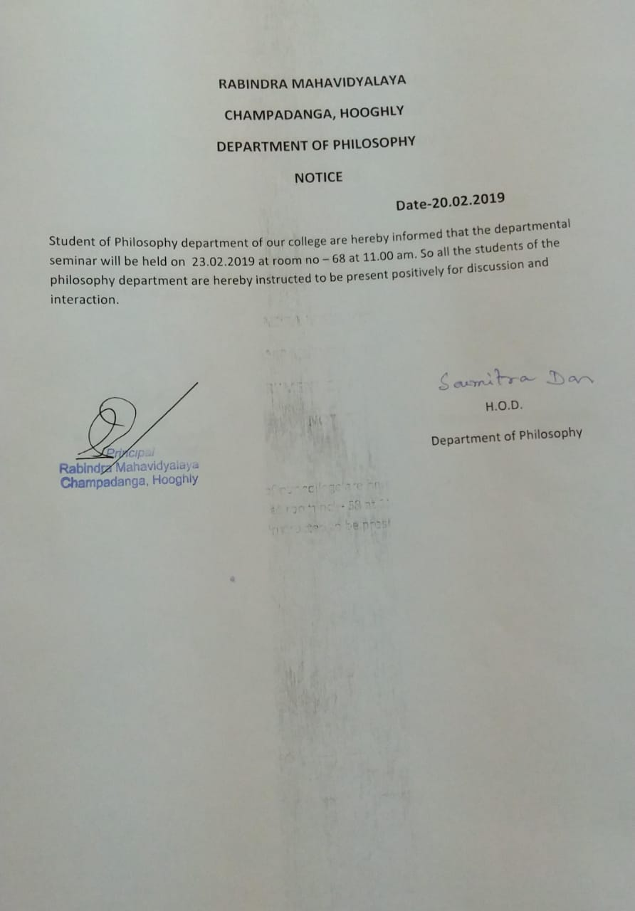

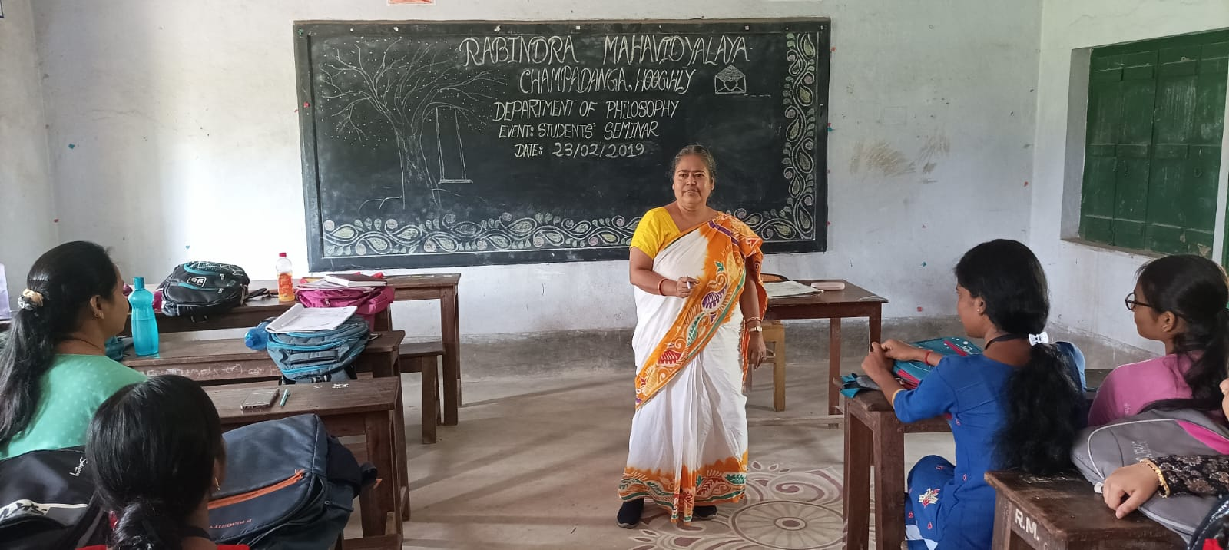
Seminar hosted by prof.SuklaSaha ,dept. of philosophy
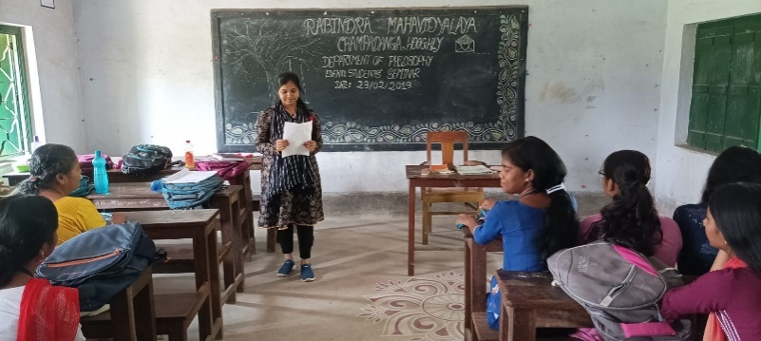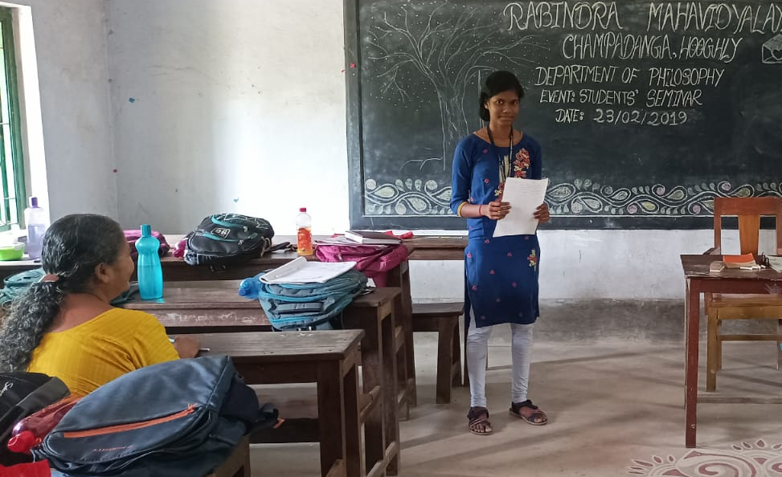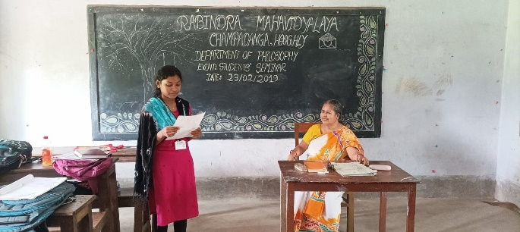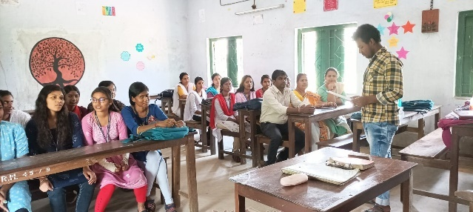
Seminar presented by the students
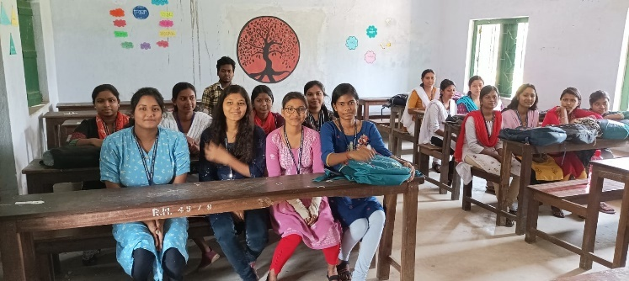

Student’s Seminar
Theme: Concept of Moksha in Indian Philosophy
Date: 23.02.2019
Venue: Department of Philosophy, Rabindra Mahavidyalaya, Champadanga
Time: 12 noon to 3 p.m.

- Inauguration
- Technical Session 1: 12.30 p.m. to 1.15 p.m.

- Chairman: Hasina Sikdar
- Rapporteur: Sima Choudhury
- Paper: Concept of Nirvana in Buddhist Philosophy
- Lunch Break

- Technical Session 2: 1.30 p.m. to 2.15 p.m.

- Chairman: Soumitra Das
- Rapporteur: Sima Choudhury
- Paper: Moksha according to Nastik Darshan

- Technical Session 3: 2.20 p.m. to 3.05 p.m.

- Chairman: Hasina Sikdar
- Rapporteur: Soumitra Das
- Paper: Nyaya Darshan-e Moksha-erDharona

- Prize Distribution
- Vote of Thanks: Prof. Hasina Sikdar

Student’s Seminar

List of Participants

Theme: Concept of Moksha in Indian Philosophy
Date: 23.02.2019
Venue: Department of Philosophy, Rabindra Mahavidyalaya, Champadanga
Time: 12 noon to 3 p.m.

- Paper: Concept of Nirvana in Buddhist Philosophy

- Presenters: Soumita Ghosh, Nisha Maity, Sumita Rana &AnushreeMaity.

- Paper: Moksha according to Nastik Darshan

- Presenters: Hriday Mondal, DebikaBhoumik, Nirmalya Mondal & Krishna Patra.

- Paper: Nyaya Darshan-e Moksha-erDharona

- Presenters: TapatiGuchhait, Banasreejana, MonamiMittir& Ankita Mondal.

Feedback Summary
- 48 responses (75%) received.
- 82% felt satisfactory.
- 90% opined the event helped to improve their academic performance.
- 75% wished to occur the events more than once every year.

What have students learnt from the event?
- Presentation skills;
- Self-confidence;
- Critical thinking;

Suggestions
- More extra-curricular activities and healthy competition;
- Special class for grooming;

